LAB PROGRAMS- OPERATING SYSTEM

- CREATE A NEW PROCESS BY INVOKING THE APPROPRIATE SYSTEM CALL. GET THE PROCESS IDENTIFIER OF THE CURRENTLY RUNNING PROCESS AND ITS RESPECTIVE PARENT USING SYSTEM CALLS AND DISPLAY THE SAME USING A C PROGRAM
AIM:
Create a new process by invoking the appropriate system call. Get the process identifier of the currently running process and its respective parent using system calls and display the same using a C program.

PROGRAM:
#include<stdio.h>
#include<unistd.h>
int main() {
printf("Process ID: %d\n", getpid() );
printf("Parent Process ID: %d\n", getpid() );
return 0;
}
OUTPUT
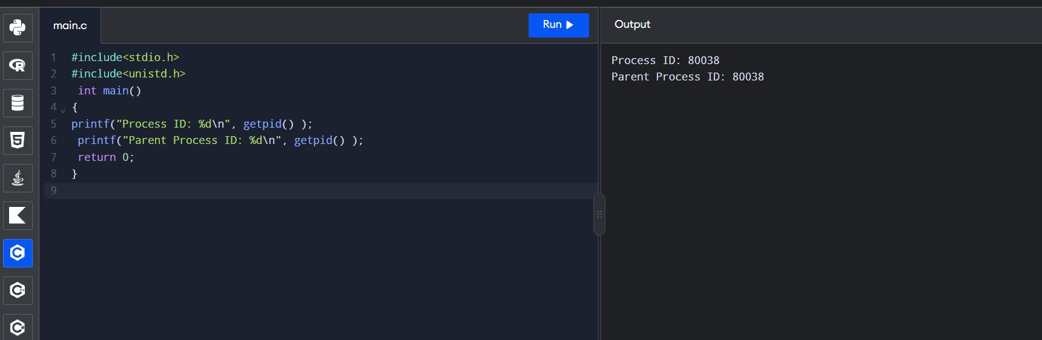
- IDENTIFY THE SYSTEM CALLS TO COPY THE CONTENT OF ONE FILE TO ANOTHER AND ILLUSTRATE THE SAME USING A C PROGRAM

AIM:
Identify the system calls to copy the content of one file to another and illustrate the same using a C program

PROGRAM:
#include <stdio.h>
#include <stdlib.h>
int main()
{
FILE *fptr1, *fptr2;
char filename[100], c;
printf("Enter the filename to open for reading \n");
scanf("%s", filename);
fptr1 = fopen(filename, "r");
if (fptr1 == NULL)
{
printf("Cannot open file %s \n", filename);
exit(0);
}
printf("Enter the filename to open for writing \n");
scanf("%s", filename);
fptr2 = fopen(filename, "w");
if (fptr2 == NULL) { printf("Cannot open file %s \n", filename);
exit(0);
}
c = fgetc(fptr1);
while (c != EOF) { fputc(c, fptr2);
c = fgetc(fptr1);
}
printf("\nContents copied to %s", filename);
fclose(fptr1);
fclose(fptr2);
return 0;
}

OUTPUT:
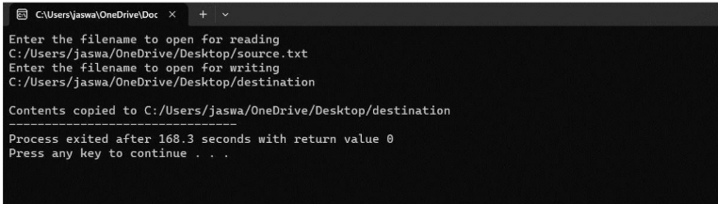

- IMPLEMENT A C PROGRAM FOR PRODUCER AND CONSUMER FOR COOPERATION PROCESS
Aim:
To implement the Bounded Buffer (Producer–Consumer) problem in C using an array as a circular buffer, demonstrating buffer insertion and deletion operations.

Program:
#include <stdio.h>
#define BUFFER_SIZE 10
int buffer[BUFFER_SIZE];
int in = 0, out = 0, count = 0;
void produce(int item)
{
if (count == BUFFER_SIZE)
{
printf("Buffer is full!\n");
return;
}
buffer[in] = item;
in = (in + 1) % BUFFER_SIZE;
count++;
printf("Produced: %d\n", item);
}
void consume()
{
if (count == 0)
{
printf("Buffer is empty!\n");
return;
}
printf("Consumed: %d\n", buffer[out]);
out = (out + 1) % BUFFER_SIZE;
count--;
}

int main()
{
int choice, item;
while (1)
{
printf("\n1. Produce\n");
printf("2. Consume\n");
printf("3. Exit\n");
printf("Enter your choice: ");
scanf("%d", &choice);
switch (choice)
{
case 1:
printf("Enter item: ");
scanf("%d", &item);
produce(item);
break;
case 2:
consume();
break;
case 3:
return 0;
default:
printf("Invalid choice!\n");
}
}
return 0;
}

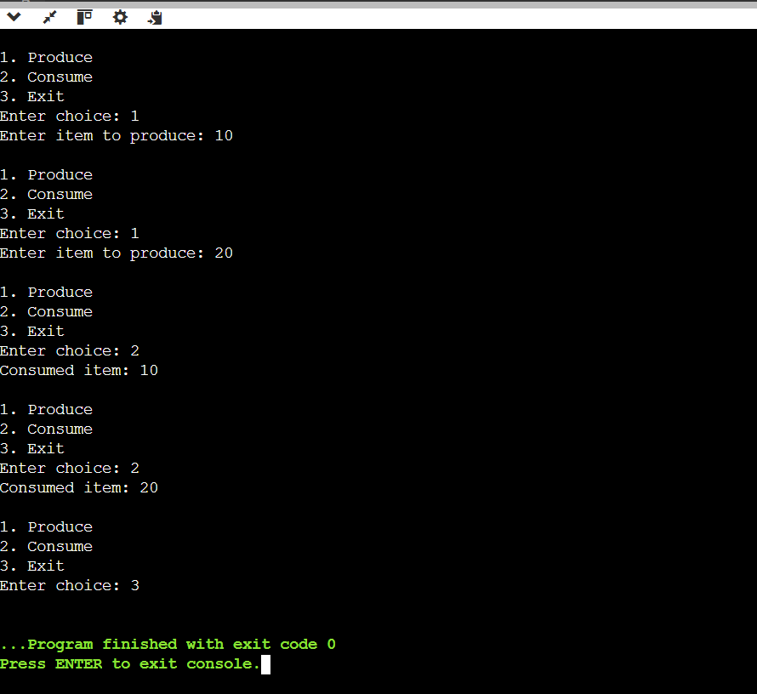Output:

- IMPLEMENTATION OF SOCKET PROGRAMMING USING TCP OR UDP
Aim:
To implement tcp socket programming in c to establish communication between a client andserver and exchange messages using socket functions

Program:
Server:
#include <stdio.h>
#include <string.h>
#include <unistd.h>
#include <sys/socket.h>
#include <netinet/in.h>
int main()
{
int s, c, n;
struct sockaddr_in addr;
char msg[100];
s = socket(AF_INET, SOCK_STREAM, 0);
addr.sin_family = AF_INET;
addr.sin_port = htons(8080);
addr.sin_addr.s_addr = INADDR_ANY;
bind(s, (struct sockaddr *)&addr, sizeof(addr));
listen(s, 1);
printf("Server waiting for client...\n");
c = accept(s, NULL, NULL);
printf("Client connected!\n");
while (1)
{
n = recv(c, msg, 99, 0);
if (n <= 0) break;
msg[n] = '\0';
printf("Client: %s", msg);
if (strncmp(msg, "bye", 3) == 0) break;
printf("Server: ");
fgets(msg, 100, stdin);
send(c, msg, strlen(msg), 0);
if (strncmp(msg, "bye", 3) == 0) break;
}
close(c);
close(s);
return 0;
}

Client :

#include <stdio.h>
#include <string.h>
#include <unistd.h>
#include <sys/socket.h>
#include <arpa/inet.h>
int main()
{
int s, n;
struct sockaddr_in server;
char msg[100];
s = socket(AF_INET, SOCK_STREAM, 0);
server.sin_family = AF_INET;
server.sin_port = htons(8080);
server.sin_addr.s_addr = inet_addr("127.0.0.1");
if (connect(s, (struct sockaddr *)&server,
sizeof(server)) < 0)
{
printf("Connection failed!\n");
close(s);
return 1;
}
printf("Connected to server!\n");
while (1)
{
printf("Client: ");
if (fgets(msg, sizeof(msg), stdin) == NULL)
break;
send(s, msg, strlen(msg), 0);
if (strncmp(msg, "bye", 3) == 0)
break;
n = recv(s, msg, sizeof(msg) - 1, 0);
if (n <= 0)
break;
msg[n] = '\0';
printf("Server: %s", msg);
if (strncmp(msg, "bye", 3) == 0)
break;
}
close(s);
return 0;
}
gcc server.c -o server
./server
gcc client.c -o client
./client

Output:
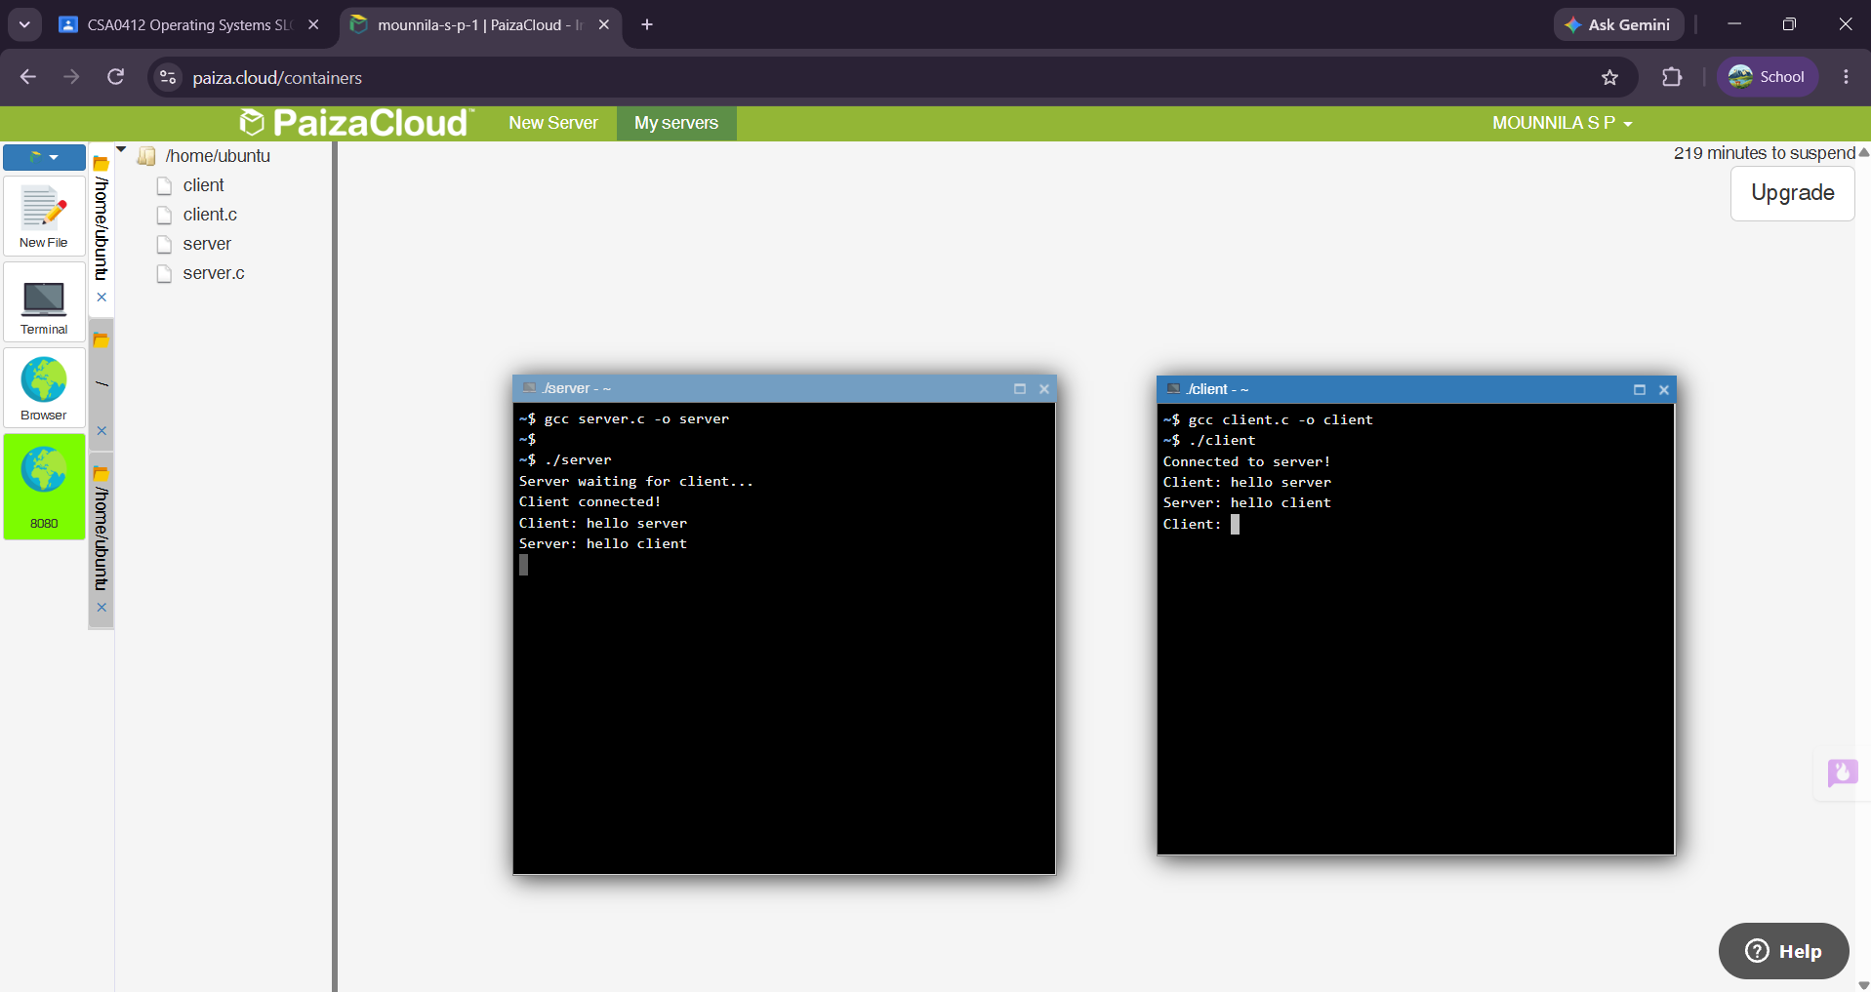

- IMPLEMENTATION OF JAVA PROGRAMMING USING MULTITHREADING

Aim:
To write a java programming using multithreading

Program:
class MyThread extends Thread {
public void run() {
for (int i = 1; i <= 5; i++) {
System.out.println(
Thread.currentThread().getName() + ": " + i
);
}
}
}
public class Main {
public static void main(String[] args) {
MyThread t1 = new MyThread();
MyThread t2 = new MyThread();
t1.setName("Thread 1");
t2.setName("Thread 2");
t1.start();
t2.start();
}
}

Output:

